Health Insurance Claim Management System for Chen’s Chinese Medicine

Pan Chen Syracuse University

**Project Summary**

I have designed a Health Insurance Claim Management System for my aunt, who runs a clinic in Camarillo, CA called Chen’s Chinese Medicine. The current one she is using is not too easy to navigate and not efficient enough: it has too much functions/options that an acupuncture clinic does not need, so it takes extra time to navigate through these redundant options input each patient’s entry. Therefore, a simple design that focuses on the insurance billing might be a good start point for my project.

My aunt is the only practitioner in the clinic with several staff members that helps her with insurance claim filing and billing. This project is set to help the clinic manage the patient’s payment to each office visit, which records the patient information and his/her insurance policy information, his/her office visits including appointment date and the description of the treatment he/she received, insurance claims information associate with his/her visits including their statuses, claim amount, and which staff member handles the claim, and the clinic staff’s information.

The design is for two user groups. One is for the business owner/the practitioner, the other one is for the staff members.

Both the practitioner and staff members could check/edit the information for the patients, their insurance policy information, their clinic visit information, the statuses of the insurance claims, the report of the claims associated with each patient, and the report of the unsettled claims’ details. The business owner could also check the summary of the staff members and the claims they are working on.

**Glossary and Data Model**

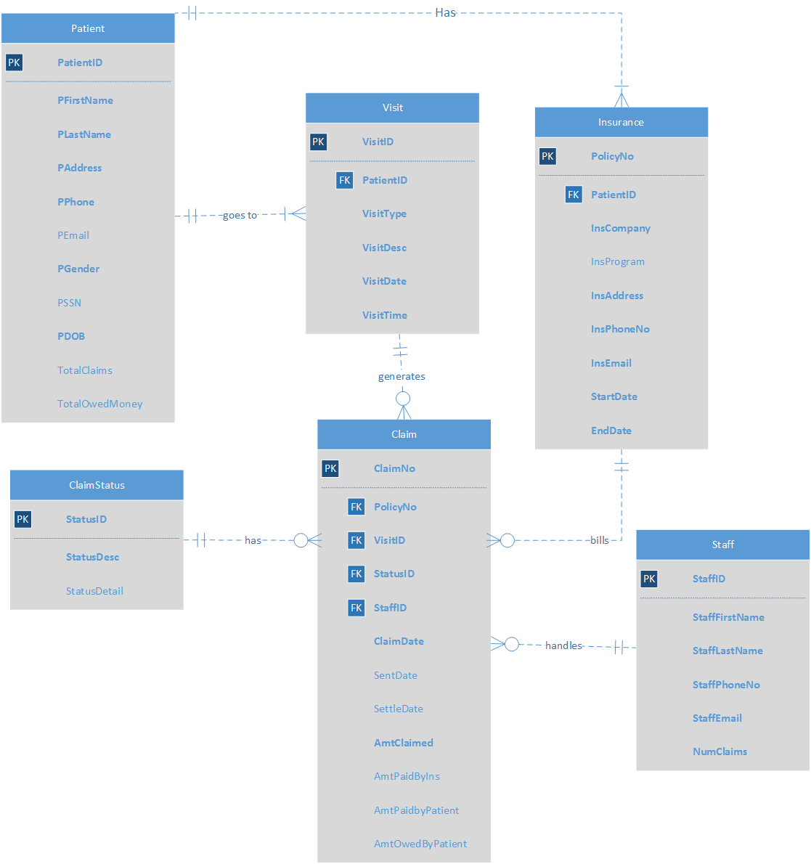

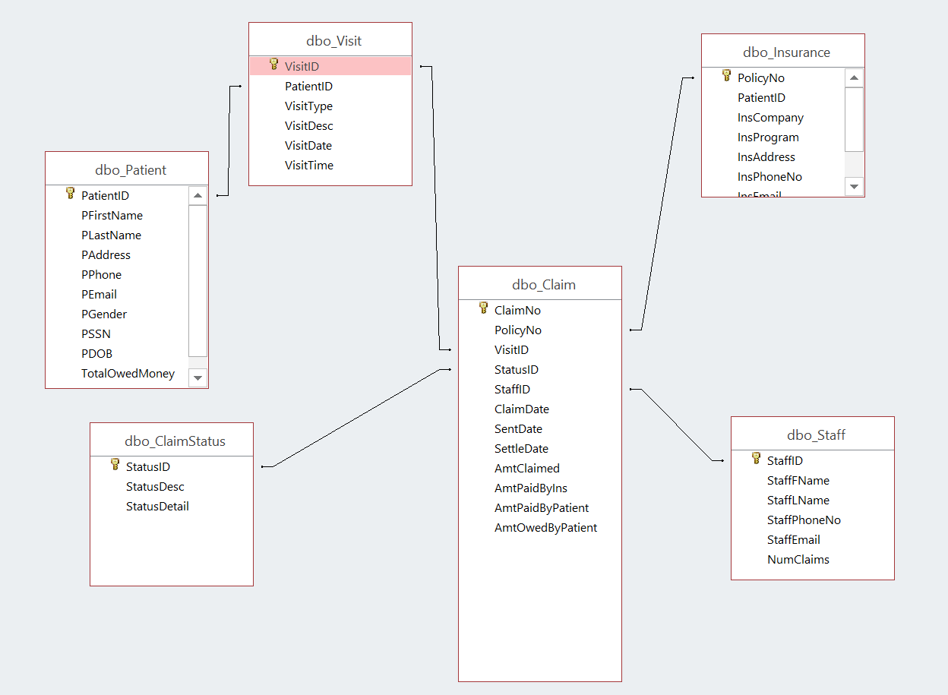

All the required attributes are in **BOLD**

|  |  |
| --- | --- |
| Data object | Explanation |
| **Patient** | Patients’ personal information |
| **PatientID (PK)** | Either DL/ID Number or Passport Number |
| **PFirstName** | Patients’ first name |
| **PLastName** | Patients’ last name |
| **PAddress** | Patient’s address |
| **PPhone** | Patient’s phone number |
| PEmail | Optional, patient’s email address |
| **PGender** | Patient’s gender |
| PSSN | Optional, patient’s Social security number |
| **PDOB** | Patient’s date of birth |
| TotalClaims | Optional, the total number of claims associated with a patient, the value is generated by a trigger. |
| TotalOwedMoney | Optional, the total amount of a patient’s unpaid balance, the value is generated by a procedure. |
| **Insurance** | Patients’ insurance policy information |
| **PolicyNo (PK)** | Patient’s Insurance Policy Number |
| **PatientID (FK)** | Associates with PatientID in **Patient** Table, a patient could have one or more insurance policies, an insurance policy is only for one patient |
| **InsCompany** |  |
| InsProgram | Insurance policy program |
| **InsAddress** | Insurance company address |
| **InsPhoneNo** | Insurance program phone number |
| **StartDate** | Policy Start Date |
| **EndDate** | Policy End Date |
| **Visit** | Patients’ office visits information |
| **VisitID (PK)** |  |
| **PatientID (FK)** | Associates with PatientID in **Patient** Table, a patient could have one or more visits, an office visit is only for one patient |
| **VisitType** | Type of visits, including Counseling, Medicine, Acupuncture, Cupping, and etc |
| **VisitDesc** | Describe the diagnosis/treatment |
| **VisitDate** |  |
| **VisitTime** |  |
| **Claim** | Details of a claim including billing information |
| **ClaimNo (PK)** |  |
| **PolicyNo (FK)** | Associates with PolicyNo in **Policy** Table, a claim can only be filed under one policy, a policy can have multiple claims |

|  |  |
| --- | --- |
| **VisitID (FK)** | Associates with VisitID in **Visit** Table, a claim can only be filed for one policy, a visit can have multiple claims |
| **StatusID (FK)** | Associates with StatusID in **ClaimStatus** Table, a claim can only have one status, a status could be from multiple claims |
| **StaffID (FK)** | Associates with StaffID in **Staff** Table, a claim can only be filed by one staff, a staff can file multiple claims |
| **ClaimDate** | The date the claim is generated |
| SentDate | Optional, the date the claim is filed |
| SettleDate | Optional, the date the claim is settled |
| **AmtClaimed** | The amount asked by the clinic for the claim |
| AmtPaidByIns | Optional, the amount of money paid by insurance |
| AmtPaidbyPatient | Optional, the amount of money paid by the patient |
| AmtOwedByPatient | Optional, the amount of money owed by the patient, automatically calculated by AmtClaimed-AmtPaidByIns-AmtPaidbyPatient. Don’t need to populate this field |
| **ClaimStatus** | Statuses of insurance claims |
| **StatusID (PK)** | Begins with either letter “N”, “D”, “P”, “S” N for not filed yet, D for Dispute (Insurance company disagrees), P for pending (insurance company paid but the patient has not), S for settled |
| **StatusDesc** | Claim Status Description, which includes dispute, settled, not filed yet and pending |
| StatusDetail | Optional, Detailed description on what this status is about |
| **Staff** | Information about staff member including the doctor herself |
| **StaffID (PK)** |  |
| **StaffFirstName** |  |
| **StaffLastName** |  |
| **StaffPhoneNo** |  |
| **StaffEmail** |  |

|  |  |
| --- | --- |
| NumClaims | Optional, Number of claims the staff member has been working on. Generated by a procedure |

**Business Rules:**

1. Each patient must have at least one insurance policy; each policy number belongs to only one patient.
2. A patient must visit the clinic at least once; the practitioner only sees one patient for a visit.
3. A clinic visit could generate multiple insurance claims or none of it, depending on its details; an insurance claim is only associated with one clinic visit.
4. Each claim has only one claim status; a claim status could be associated with multiple claims
5. Each claim only bills one insurance policy; the clinic can file multiple policies under one insurance claim.
6. A staff member could file multiple claims; a claim could only be handled by one staff member.

**SQL script for creating tables and inserting sample data**

I will demonstrate the data-insertion by creating a patient called Chris Paul, who has two claims, and he paid one of them and has not paid the other one yet.

The claim will be handled by a staff member called Jamal Crawford.

**CREATE: Patient**

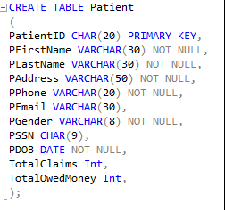

**Insert Data in PATIENT Table:**



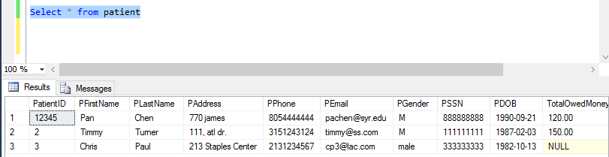

**CREATE: Insurance**

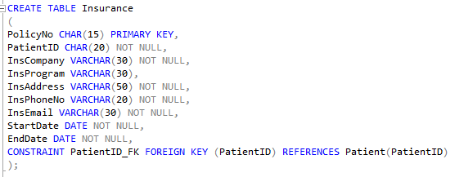

**Insert Data in Insurance Table:**



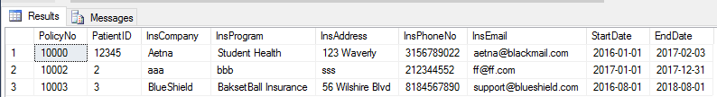

**Create: Visit**

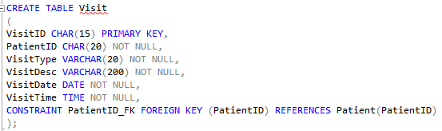

**Insert Data in Visit Table:**



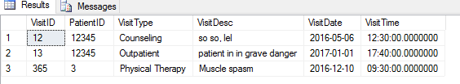

**CREATE: Staff**

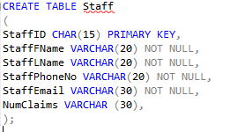

**Insert Data in Staff Table:**



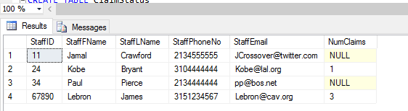

**CREATE: ClaimStatus**

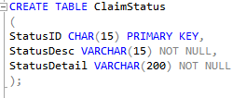

**Insert Data in ClaimStatus Table:**



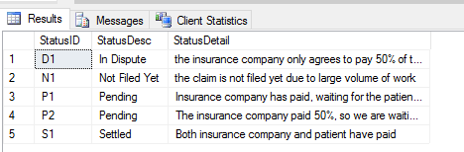

**CREATE: Claim**

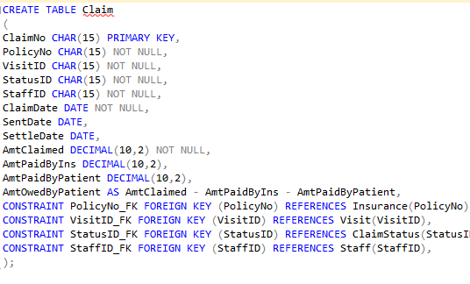

**Insert Data in Claim Table:**

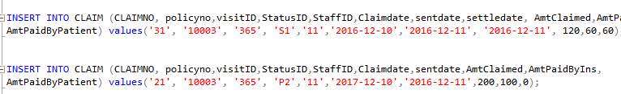

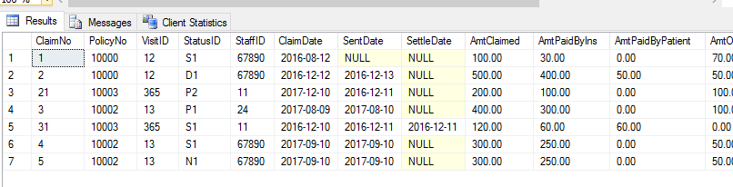

**Section V**: **SQL statements for answering major data questions using reports**. **Required to have at least one Data Question with Aggregate Functions** (2 points)

Major Data Questions:

1. Check all the unsettled claims with detail

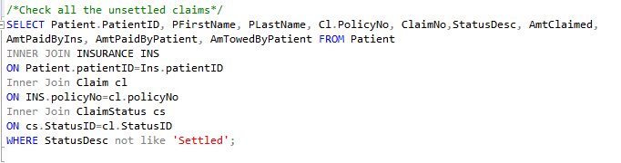

Report:

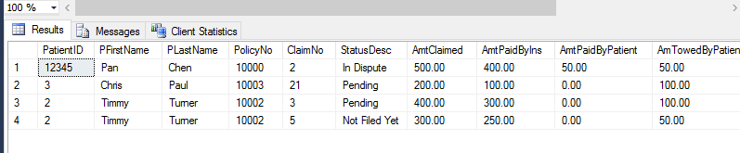

1. Check claims associated with each patient, and how much does each of the patient owe the clinic

Totalclaims is an aggregate field

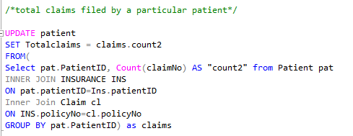

totalowed is a stored procedure

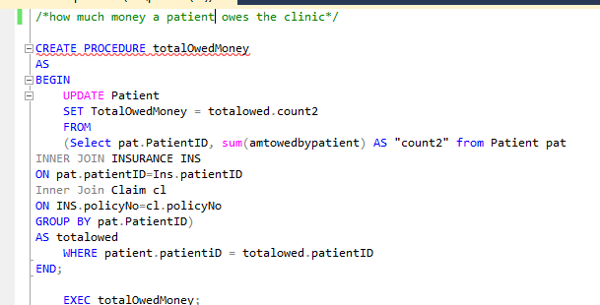

After running the function, the report looks like :

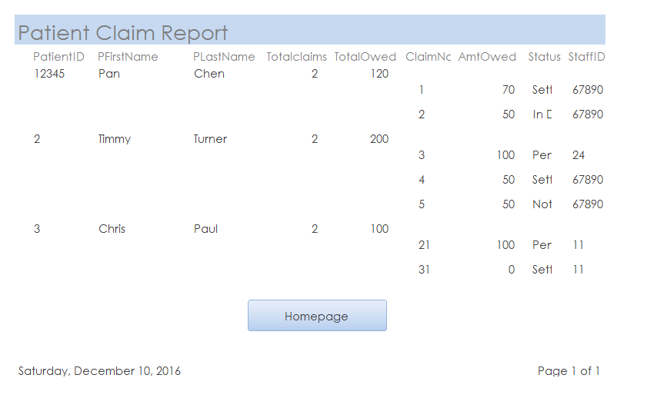

1. Check what claims is each of the staff member working on, and how many claims each of the staff member is working on

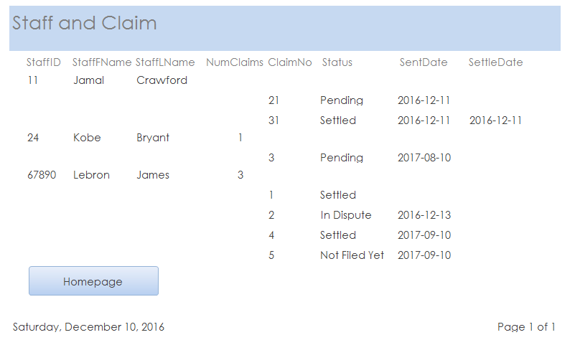

NumClaims is an aggregate procedure

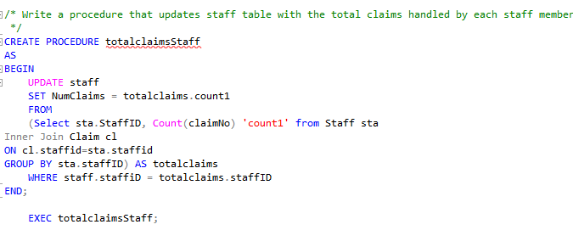

After running the procedure, the report looks like:

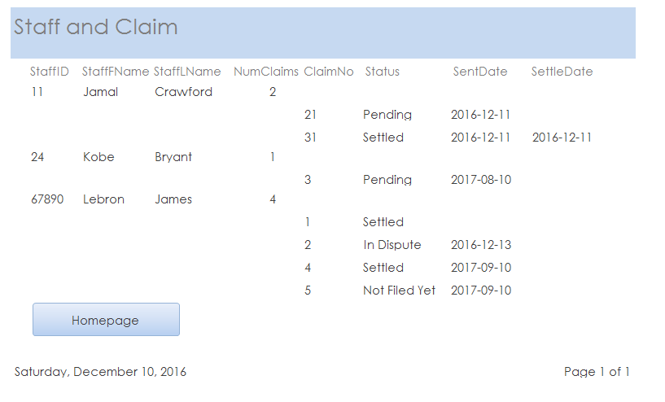

**Interfaces**

Create forms (with at least one combo box) and reports for users to perform data input and output easily. Include the screen copy of all forms and reports. Add captions to explain the purpose of each form or report. You should generate reports for the major data questions in Section VI.

This is the homepage for my system, both the practitioner and staff member could use it, although the staff member is not able to access the general staff performance report

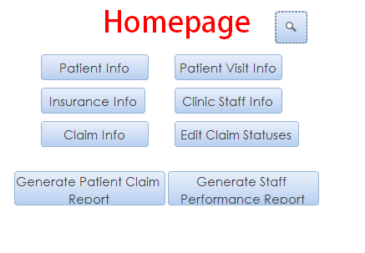

Click on “Patient Info” -> The patient information form: view and edit each patient’s detailed personal information

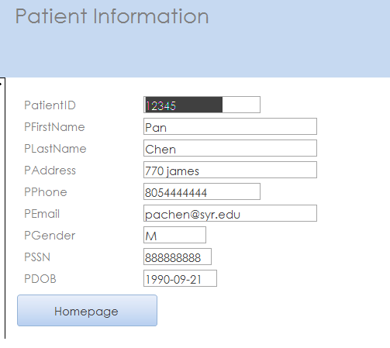

Click on Insurance info -> The policy information form: view and edit information of patients’ policies.

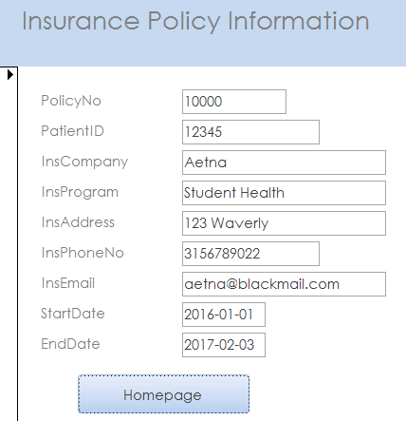

Click on Patient Visit Info -> The policy information form: view and edit information of patients’ clinic visits

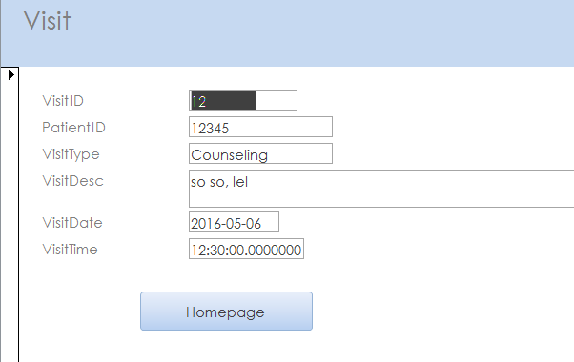

Click on “Edit Claim Status” -> The Claim Status form: view and edit descriptions of different claims statuses

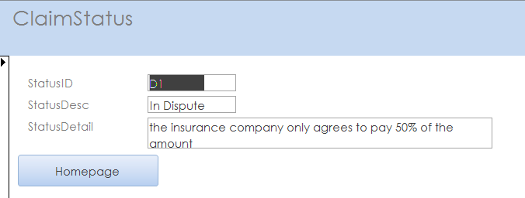

Click on “Claim info” -> The Claim form: view and edit descriptions of different insurance claims

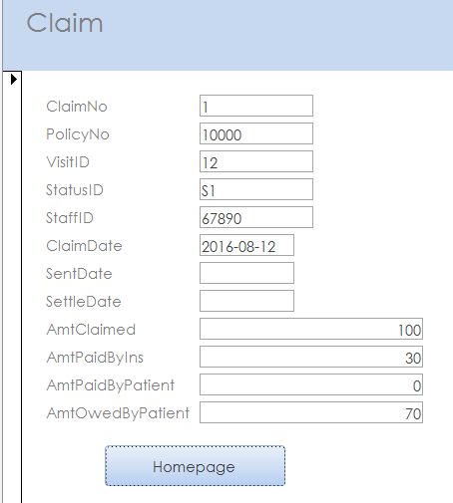

Click on “Clinic Staff Info” -> The staff form: view and edit each staff member’s information

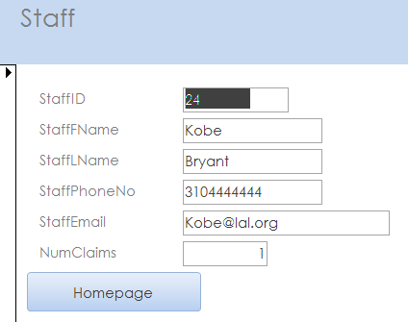

Click on ../../Pictures/Screenshots/Screen%20Shot%202016-12-09%20at%205.05.54%20PM.pn -> Patient Search: Search each patient’s total owed money and their claims’ statuses by selecting Patient’s ID

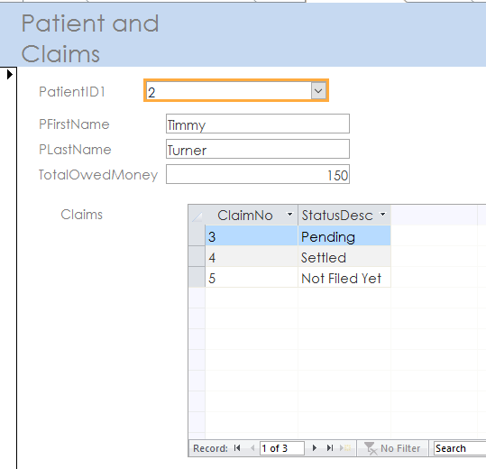

**Trigger**

This trigger updates the number of claims from patients when a new claim for him/her entry is created or deleted

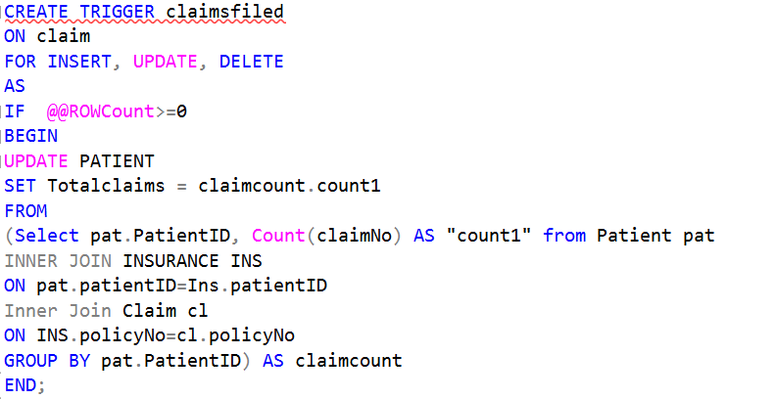

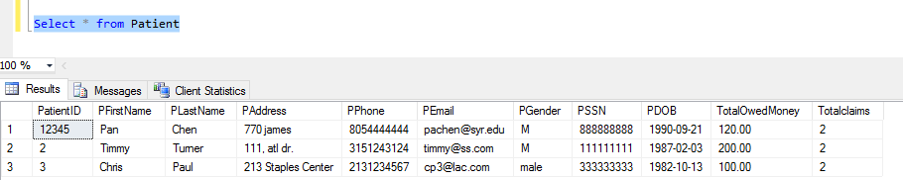

Now we delete one

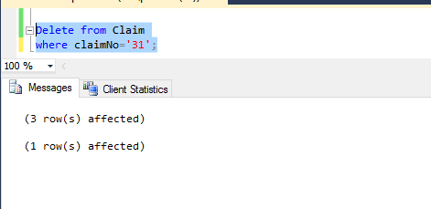

Now the number of his claims is updated

